Task 2:Kidney Disease Prediction Using Machine Learning

Objective
To develop a machine learning model for predicting Chronic Kidney Disease (CKD) using patient health records to support early diagnosis.

Description
Developed a machine learning model using a kidney disease dataset. The project included preprocessing medical data, training multiple algorithms, evaluating model performance, and predicting disease status.

Technologies Used
- Python
- Jupyter Notebook
- Pandas
- NumPy
- Matplotlib
- Scikit-learn

Activities Performed
- Loaded the kidney disease dataset.
- Cleaned missing and inconsistent values.
- Encoded categorical features where required.
- Performed Exploratory Data Analysis (EDA).
- Split the dataset into training and testing sets.
- Trained machine learning models:
  - Decision Tree
  - Random Forest
  - AdaBoost
- Compared model accuracies.
- Predicted kidney disease using new patient data.

- Outcome
Successfully developed a kidney disease prediction model capable of classifying patients as having Chronic Kidney Disease or not.

Skills Acquired
- Data Cleaning
- Feature Engineering
- Machine Learning
- Decision Tree
- Random Forest
- AdaBoost
- Model Evaluation
- Healthcare Data Analysis

Output
- Displayed correlation heatmap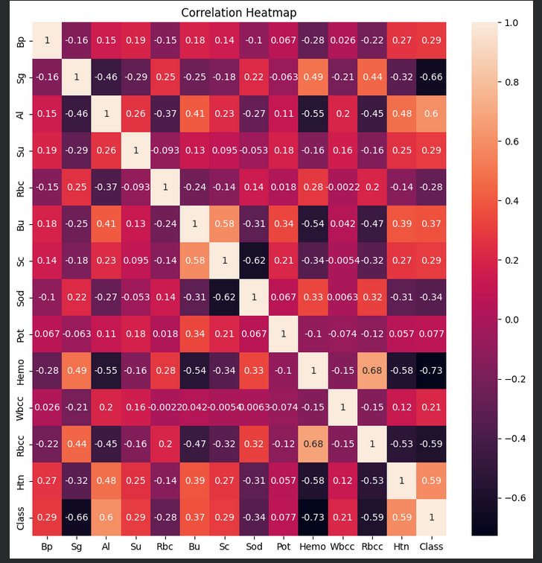

- Predicted whether a patient has Chronic Kidney Disease (CKD) or not based on medical attributes

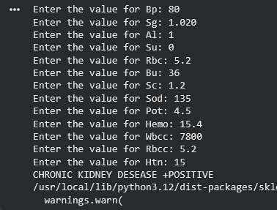
- Compared the performance of different machine learning models.
- 